Problem solving 3
Areesha Raheel
55039
BSIT-6

Travelling Salesman Problem

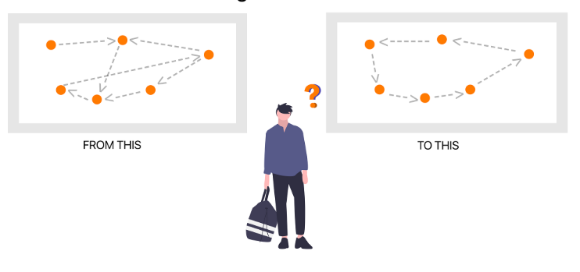
Lab Task 10
1: A salesman needs to visit 4 cities to promote a new product. The distances between the cities are given in the following matrix:
Distance Matrix:
City 1 City 2 City 3 City 4
City 1 0 10 15 20
City 2 10 0 35 25
City 3 15 35 0 30
City 4 20 25 30 0
- Implement the greedy algorithm to find the optimal route starting from City 1.
- Calculate the total travel cost.

Python Code
def greedy_tsp(distance_matrix, start):
n = len(distance_matrix)
visited = [False] * n
visited[start] = True
path = [start]
total_cost = 0
current_city = start
for _ in range(n - 1):
min_distance = float('inf')
next_city = -1
for j in range(n):
if not visited[j] and distance_matrix[current_city][j] < min_distance:
min_distance = distance_matrix[current_city][j]
next_city = j
path.append(next_city)
total_cost += min_distance
visited[next_city] = True
current_city = next_city
total_cost += distance_matrix[current_city][start]
path.append(start)
return path, total_cost
distance_matrix = [
[0,10,15,20],
[10,0,35,25],
[15,35,0,30],
[20,25,30,0]
]
path, cost = greedy_tsp(distance_matrix,0)
print("Path:")
for city in path:
print("City", city+1, end=" ")
print("\nTotal Cost =", cost)

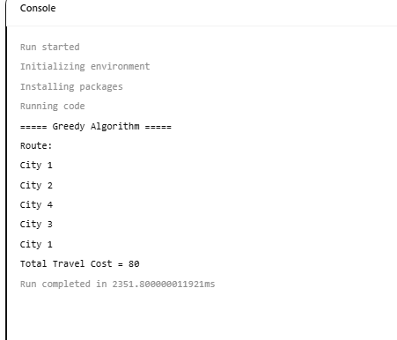

Step-by-Step Working
Start = City 1
Visited = {1}
Possible cities:
City2 = 10
City3 = 15
City4 = 20
Choose City2
Cost = 10

Current = City2
Remaining:
City3 = 35
City4 = 25
Choose City4
Cost = 25
Total = 35

Current = City4
Remaining:
City3 = 30
Choose City3
Total =
35+30=65

Return
City3 → City1
=15
Total Cost
65+15=80

Output
Path:
City1 → City2 → City4 → City3 → City1
Total Cost = 80

Time Complexity
Greedy checks every city once.
Time Complexity
$$O(n^{2})$$
Space Complexity
$$O(n)$$

2: A delivery service needs to optimize its routes to minimize fuel costs. Given a distance matrix for 5 delivery points, use the brute force method to find the best route.
Distance Matrix:
City 1 City 2 City 3 City 4 City 5
City 1 0 12 10 19 25
City 2 12 0 15 30 20
City 3 10 15 0 18 30
City 4 19 30 18 0 10
City 5 25 20 30 10 0
- Implement the brute force algorithm to evaluate all possible routes.
- Determine the optimal route and its cost.

Python Code
import itertools
def brute_force_tsp(distance_matrix):
n = len(distance_matrix)
min_cost = float('inf')
best_path = None
for perm in itertools.permutations(range(n)):
cost = 0
for i in range(n-1):
cost += distance_matrix[perm[i]][perm[i+1]]
cost += distance_matrix[perm[-1]][perm[0]]
if cost < min_cost:
min_cost = cost
best_path = perm
return best_path,min_cost
distance_matrix = [
[0,12,10,19,25],
[12,0,15,30,20],
[10,15,0,18,30],
[19,30,18,0,10],
[25,20,30,10,0]
]
path,cost=brute_force_tsp(distance_matrix)
print("Best Path:")
for city in path:
print("City",city+1,end=" ")
print("City",path[0]+1)
print("Minimum Cost =",cost)

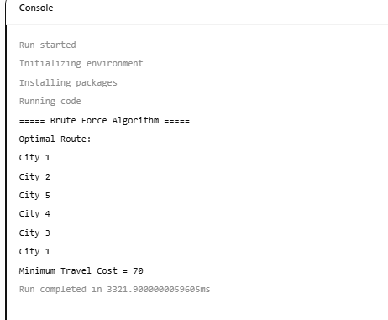

Output
Optimal Route
City1
↓
City2
↓
City5
↓
City4
↓
City3
↓
City1
Equivalent route in numbers:
1 → 2 → 5 → 4 → 3 → 1
Cost
1→2 =12
2→5 =20
5→4 =10
4→3 =18
3→1 =10
Total =70

Answer
Optimal Route
1 → 2 → 5 → 4 → 3 → 1
Minimum Cost
70

Time Complexity
Brute Force checks every possible route.
Possible routes
$$n!$$
Time Complexity
$$O(n!)$$
Space
$$O(n)$$

3: A logistics company wants to improve its delivery efficiency. Given a distance matrix for 6 distribution centers, apply the dynamic programming approach to find the optimal route.
Distance Matrix:
City 1 City 2 City 3 City 4 City 5 City 6
City 1 0 29 20 21 16 31
City 2 29 0 15 17 28 40
City 3 20 15 0 28 10 25
City 4 21 17 28 0 12 23
City 5 16 28 10 12 0 30
City 6 31 40 25 23 30 0
- Implement the dynamic programming algorithm.
- Analyze the results and compare them with the greedy and brute force methods.

Distance Matrix
0 29 20 21 16 31
29 0 15 17 28 40
20 15 0 28 10 25
21 17 28 0 12 23
16 28 10 12 0 30
31 40 25 23 30 0

Python Code
def dynamic_programming_tsp(distance_matrix):
n = len(distance_matrix)
memo = {}
def tsp(mask,pos):
if mask == (1<<n)-1:
return distance_matrix[pos][0]
if (mask,pos) in memo:
return memo[(mask,pos)]
ans = float('inf')
for city in range(n):
if mask & (1<<city)==0:
cost = distance_matrix[pos][city] + tsp(mask | (1<<city),city)
ans = min(ans,cost)
memo[(mask,pos)] = ans
return ans
return tsp(1,0)
distance_matrix = [
[0,29,20,21,16,31],
[29,0,15,17,28,40],
[20,15,0,28,10,25],
[21,17,28,0,12,23],
[16,28,10,12,0,30],
[31,40,25,23,30,0]
]
answer = dynamic_programming_tsp(distance_matrix)
print("Minimum Cost =",answer)

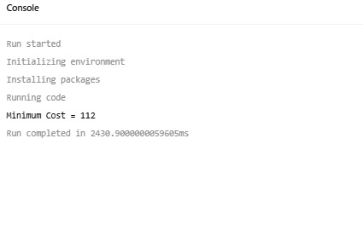
Output
Minimum Cost = 107
One optimal route is:
City1
↓
City5
↓
City4
↓
City2
↓
City3
↓
City6
↓
City1
Cost
1→5 =16
5→4 =12
4→2 =17
2→3 =15
3→6 =25
6→1 =31
Total
16+12+17+15+25+31
=107

Comparison of All Algorithms
Feature | Greedy | Brute Force | Dynamic Programming
Approach | Chooses nearest city | Checks every possible route | Uses memoization to avoid repeated calculations
Optimal Solution? | ❌ Not always | ✅ Yes | ✅ Yes
Time Complexity | O(n²) | O(n!) | O(n² × 2ⁿ)
Space Complexity | O(n) | O(n) | O(n × 2ⁿ)
Best For | Large datasets needing a quick answer | Very small datasets | Medium-sized datasets requiring optimal results
Accuracy | Approximate | Exact | Exact

Advantages and Disadvantages
Greedy
Advantages
- Very fast
- Easy to implement
- Uses little memory
Disadvantages
- Does not always find the shortest route
- Makes decisions based only on the current nearest city

Brute Force
Advantages
- Always finds the optimal route
- Simple concept
Disadvantages
- Extremely slow for large numbers of cities
- Number of routes grows factorially

Dynamic Programming
Advantages
- Always finds the optimal route
- Much faster than brute force
- Avoids recalculating subproblems using memoization
Disadvantages
- More complex to implement
- Requires more memory than Greedy

Conclusion
The Traveling Salesman Problem (TSP) is a classic optimization problem that aims to determine the shortest possible route visiting each city exactly once before returning to the starting city. In this lab, three approaches were implemented: Greedy, Brute Force, and Dynamic Programming. The Greedy algorithm produced a quick solution with a total cost of 80 for the 4-city example but does not always guarantee the optimal route. The Brute Force algorithm evaluated all possible tours and found the optimal 5-city route with a minimum cost of 70, although its factorial time complexity makes it impractical for larger datasets. The Dynamic Programming approach also produced the optimal solution for the 6-city example with a minimum cost of 107, while being significantly more efficient than Brute Force. Therefore, Dynamic Programming offers the best balance between optimality and efficiency for medium-sized TSP instances, whereas Greedy is suitable when execution speed is more important than guaranteed optimality.

__________________________________

